My first issue:

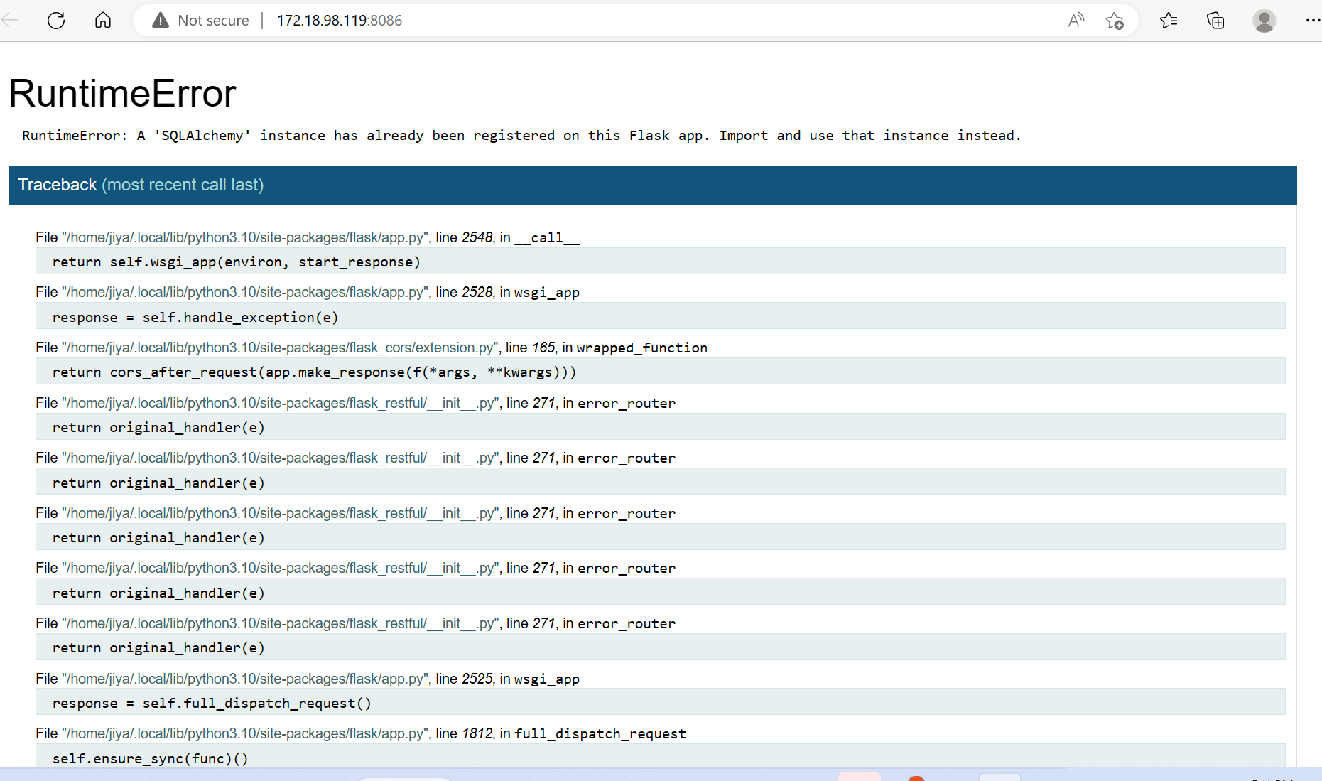

Other Error:

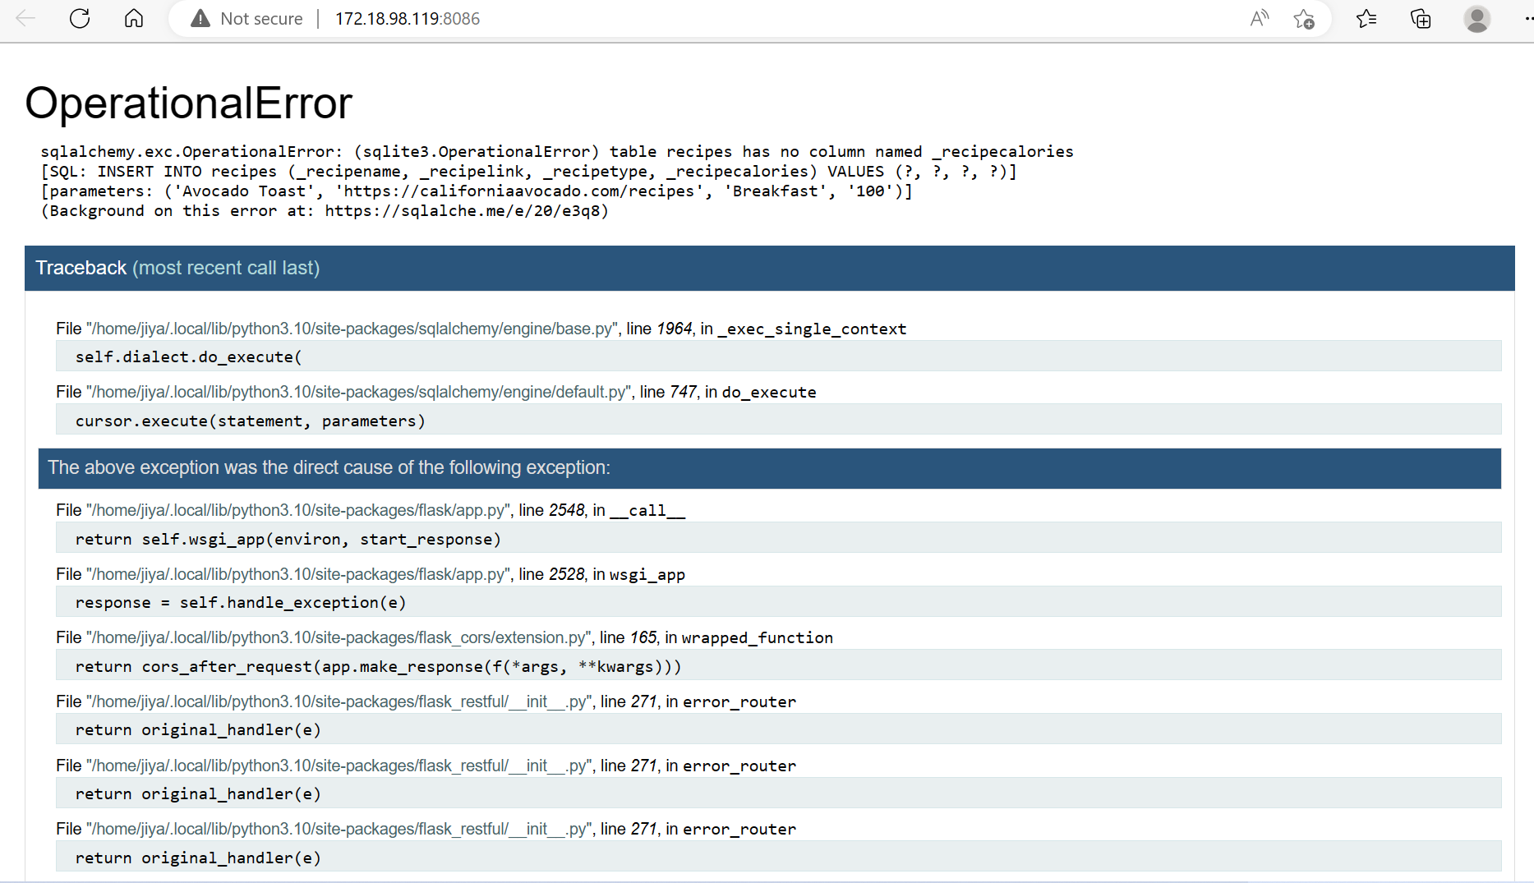

What help said (not under my control):  
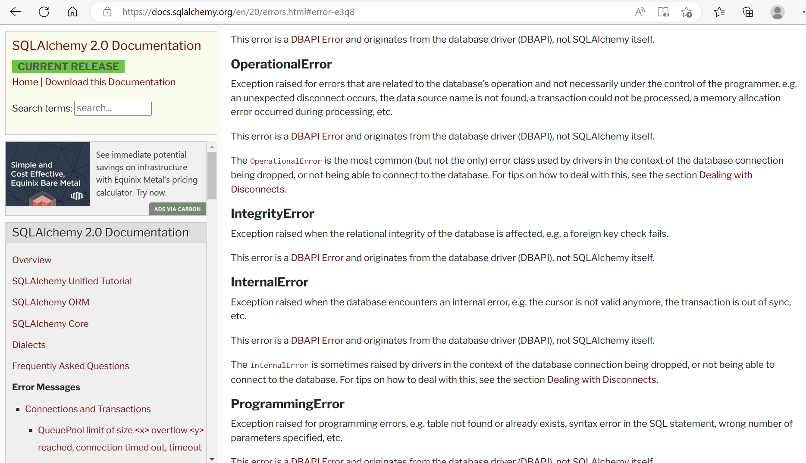

To fix the operational error, I tried many methods. I tried to follow the instructions on slack:

* Fix #1: fixing SQLAlchemy upgrade that changed syntax on how to perform db.create_all(); must be inside an with app.app_context():
* Fix #2: default location for databases inside an instance folder; changing the impacted docker-compose.yml

Also, I tried removing the db.init_app(app) lines in each of our api files.

Finally, I got it to work after recoding the entire api files for recipe.py, recipes.py, and main.py. The flask was running smoothly, and I was even able to connect it to postman:

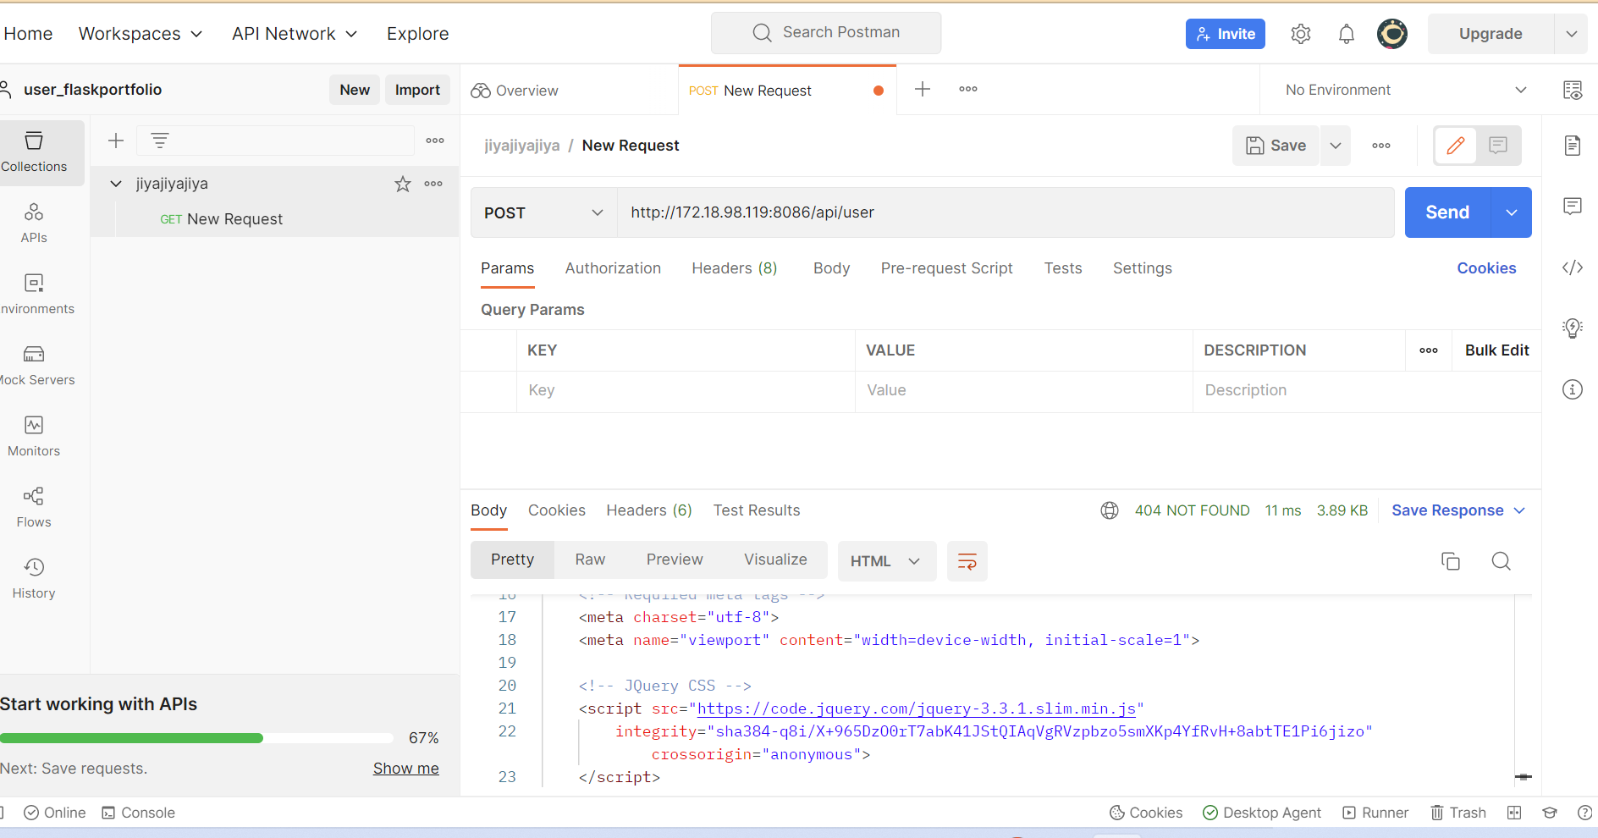

Unfortunately, now the flask is not able to run, so I can’t connect it to my front end. However, it is an easy fix to fetch the api, and I even included a section for it in my current code:

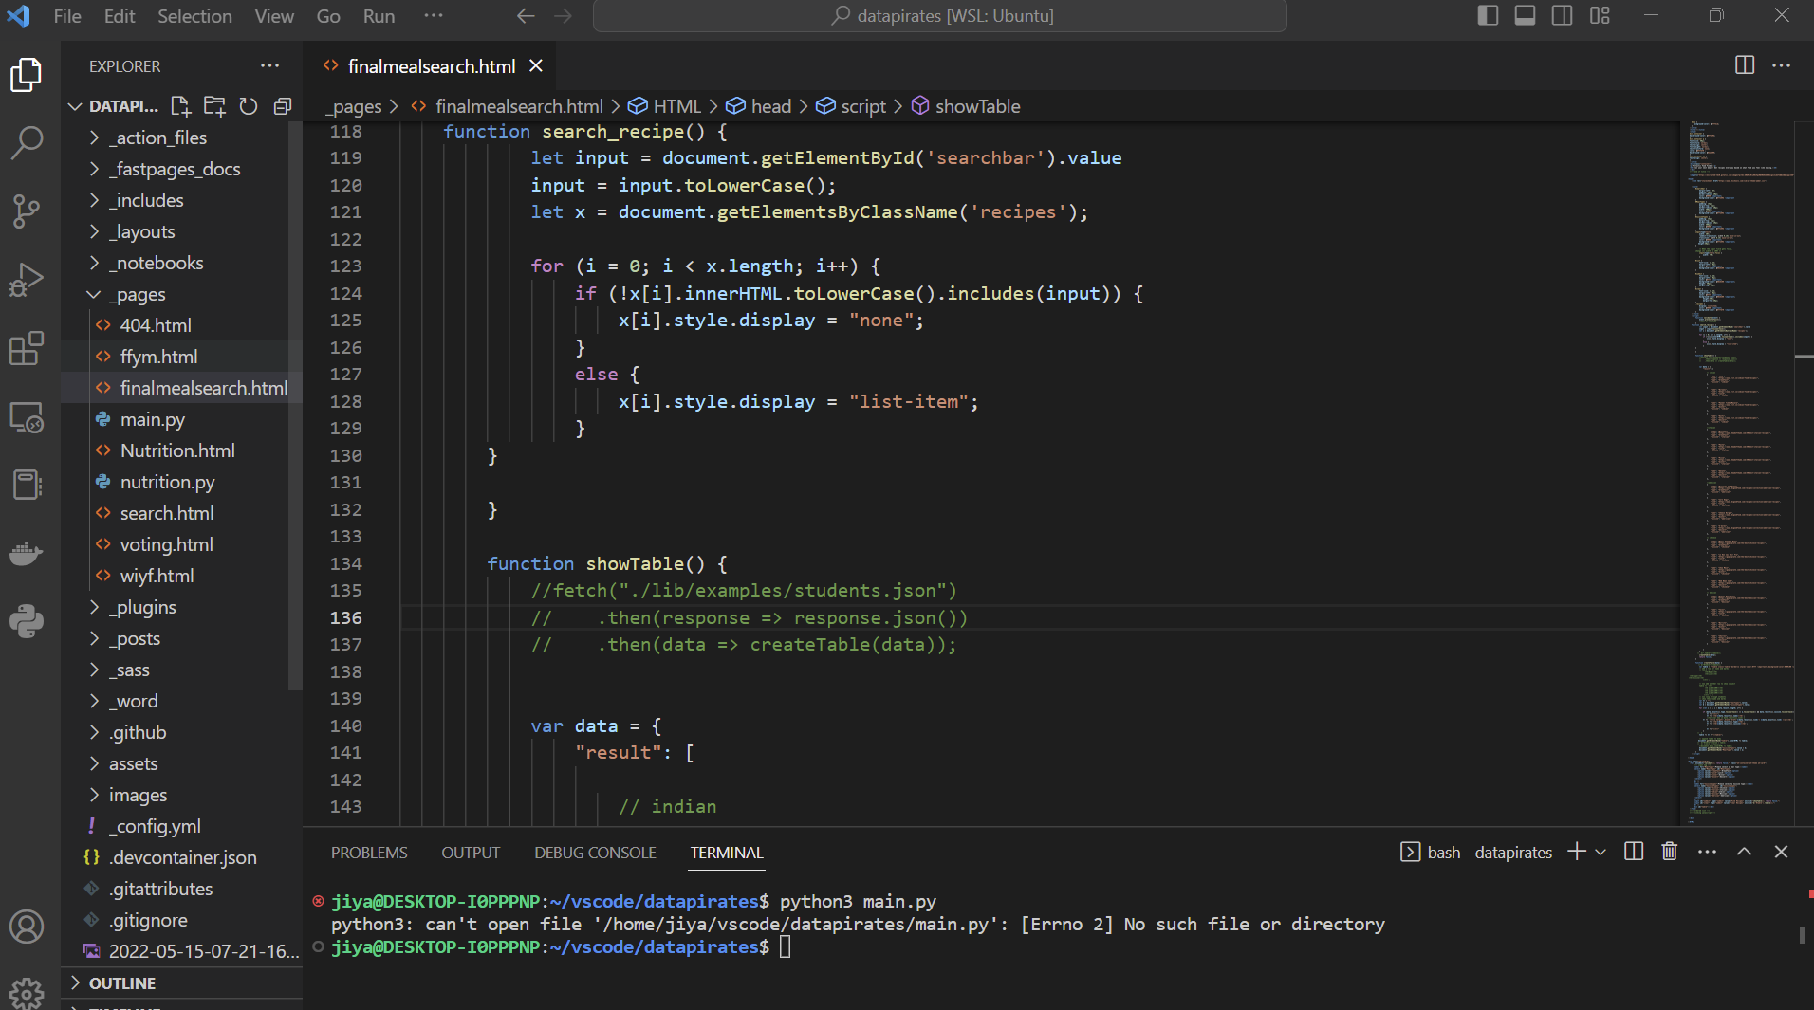

My current error:

